vetmed_logo_RGB.eps

University of Veterinary Medicine, Vienna

Veterinaerplatz 1

1210 Vienna

Austria

Results for the Competence Screening of the Postgraduate Programme in Renewable Energy at Carl von Ossietzky-University Oldenburg

**Screening of competences**

April 2018

Preusche, Finsterwald

# Short description of the survey

|  |  |
| --- | --- |
| **Aim** | **Screening of competences** |
| **Instrument** | * Online Questionnaire based on the Competence Screening Questionnaire for Higher Education (CSQ-HE) * Called “competence check” at the Vetmed Vienna |
| **Population** | * Students and teaching faculty members in the 6th semester of the study programme in veterinary medicine[[1]](#footnote-1) |
| **Procedure** | Students and teaching faculty members were invited to participate in the online survey. Students filled out the survey during a regular class session, while teaching faculty members were invited via email and filled out the CSQ-HE on their own computers. |
| **Response rate** | * Students (N): 185 of 190 invited persons; 97% * Faculty members (N): 25 of 99 invited persons; 25% |
| **Timeframe** | June - July 2017 |

# Executive summary

## Introduction

The so-called “competence check” is a screening instrument for quality assurance in university teaching. Quality assurance is governed by the University Act 2002 §14.

In 2012, the European Association of Establishments for Veterinary Education (EAEVE) audited university teaching at the Vetmeduni Vienna and recommended in their concluding report that new evaluation tools that incorporate student progress as well as the perspectives of external lecturers and graduates of Vetmeduni Vienna have to be developed.

Evaluating the curriculum via the competence check is also anchored in the 2014 Curriculum for the Diploma Programme in Veterinary Medicine as one of three evaluation measures and is listed as a strategic goal in the Development Plan 2025 of the Vetmeduni Vienna.

In order to get a comprehensive picture on competence development, and as recommended in the EAEVE final report, both students and members of the teaching faculty (including instructors) are surveyed. Students in their 6th and 10th semesters and the faculty members who teach them are invited to participate in the survey.

All participants are asked to provide (self-)assessments of the areas of competence defined in the Vetmeduni Vienna’s competence model:

1. Personal competences
2. Medical competences
3. Scientific competences
4. Economic competences
5. Societal competences

Conducting the survey should answer the evaluation question of whether students acquired the intended competence levels of the study programme and whether the study programme adequately promotes the students’ competences. The evaluation results should enable the Vetmeduni Vienna to detect the strengths and weaknesses of the study programme, which can then be tackled by developing quality assurance and quality enhancement measures.

## Main results

Overall, the students and teaching faculty members rated the attainment of the intended competence levels in the 5 areas of competences as "moderate" (50% of the intended values were achieved; aggregation of the perspectives of student and teaching faculty members). The practical component was estimated to have been achieved slightly more often (54.4% of the target values achieved) than the cognitive component (46.3% of the target values achieved on average). The overall results are summarized in Table 1.

***Table 1: Attainment of the intended values of the cognitive and practical components for each area of competence (average ratings of students & teaching faculty members) in the 6th semester***

|  |  |  |  |  |  |  |
| --- | --- | --- | --- | --- | --- | --- |
|  | **COGNITIVE** | | | **PRACTICAL** | | |
| **Area of competences** | **Rating** | **%** | **Number of competences****[[2]](#footnote-2)** | **Rating** | **%** | **Number of competences2** |
| Personal competences | many | 82 | 11 | some | 65 | 10 |
| Medical competences | some | 42 | 31 | some | 48 | 26 |
| Scientific competences | few | 20 | 5 | some | 60 | 5 |
| Economic competences | few | 33 | 3 | few | 0 | 1 |
| Societal competences | few | 25 | 4 | many | 83 | 3 |

*Interpretation: few = 0-33% of the intended values were reached; some = 34-66% of the intended values were reached; many = 67-100% of the intended values were reached.*

Furthermore, the results showed that:

* The practical component of the competences was attained slightly more frequently than the cognitive component. But the levels for the practical component were set lower than those for the cognitive component. Thus, they can be achieved somewhat more easily.
* Students (and teaching faculty members) often rated the taught competence level as lower than (or otherwise similarly to) the "actual" acquired competence level. Thus, the results indicate that students do not realize what they are being taught within their study programme with respect to some competences.
* In most cases, the gap between the intended and achieved levels was no larger than one level. This means that the study programme is generally successful. But there are still a few competences where larger deviations (more than 1 level) from the intended levels appeared from the perspectives of both students and teaching faculty members. These major deviations ​​are in the area of medical competences (e.g. hygienic work).

## Conclusions

In conclusion, one can say that the study programme is generally successful in achieving the intended competence levels.

However, improvements can still be made. In a first step, the study programme should focus on the few competences where major deviations appeared. Stakeholders should reflect on the curriculum design (Where in the curriculum or in which courses are these competences actually addressed? Is there sufficient time to reach the competences? etc.), students’ skills (Do students have enough prior knowledge? Do they have sufficient learning skills? etc.) and teaching methods (Should teachers change or adapt their teaching methods? etc.)

In a second step, it could be helpful to take a look at the competences themselves: Should the wording / examples be changed to make them easier to understand? Were the levels (set before the curriculum was introduced) realistic?

In a third step, stakeholders should consider whether the Vetmeduni Vienna’s competence model should be revised. The further development of the screening instrument within the IQM-HE project could provide helpful further information here.

Waiting for the results of the Competence Check 2018 (and the Competence Check 2019, if possible) is recommended before implementing Steps 2 and 3 because screening results from the 10th semester will be available and integrated in the revision / adaptation process at that point.

The template was developed in the course of the project

‘Internal Quality Management: Evaluating and Improving Competence-Based Higher Education‘

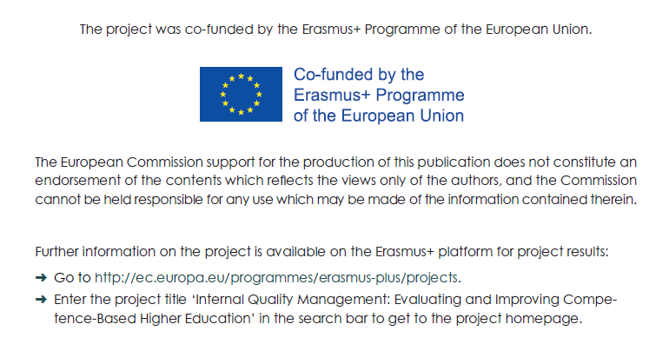

1. Students and teaching faculty members in the 10th semester of the study programme in veterinary medicine were also surveyed; those screening results are not presented in this report, because students of the 10th semester were still trained based on the former curriculum. [↑](#footnote-ref-1)
2. This summary takes into account the students’ self-assessments and the teaching faculty members’ external assessments. Competencies with target values at level 0 and students’ evaluation of the curriculum (=taught competences) were excluded. [↑](#footnote-ref-2)